**Guidelines for the preparation of Summer Internship report**

1. **Guidelines for formatting of the report** 
   * The report should be prepared on A4 letter size.
   * The font type should be Times New Roman. The font size should be 14 for headings and 12 for normal text.
   * All the headings should be in bold and all the other matter should be normal.
   * The text should be justified throughout the report except for headings for figures, tables, schemes etc.
   * The line spacing should be fixed at 1.5 for the entire report.
   * The page numbers should be mentioned at bottom middle position.
   * The top, bottom and right margins should be 1” each whereas the left margins should be set at 2.5”.
   * The chapters should be numbered as Chapter-1, Chapter-2, etc. whereas figures, charts, tables etc. should be numbered as 1.1, 2.1 etc. For example- figure 1.1 corresponds to first figure in chapter-1.
   * The hard copy of the report should be spiral bound with first page as thick cover.
   * The report should be minimum of 40 pages and maximum of 60 pages.
2. **Categorization of chapters**

The report should be divided into minimum of 4 chapters. The number of chapters can be increased to maximum of 7 depending upon the requirement and nature of the work undertaken by the students. The suggestive guidelines for each chapter are as follows:

* + **Chapter-1:** Chapter-1 should be titled as “**INTRODUCTION OF THE PROJECT UNDERTAKEN”**. It should include the objectives, importance and applicability, scope, relevance etc. of the proposed work. This may also include the work plan and the implementation part.
  + **Chapter-2 or more:** Chapter-2 or more chapters can be on the work done by the student during his/her Summer Internship period. Each Chapter must be given appropriate title. The tables, figures, schemes etc. should appear in the report as and where they are required with proper labeling.
  + **Final Chapter:** The final chapter should be titled as “**CONCLUSION**”. This chapter may include the summary of the findings and key observations during the Summer Internship to attain the objectives as mentioned in Chapter-1. This chapter should also discuss about the future scope and applicability of the outcome of the Summer Internship.

**Guidelines for writing references**

* + The references should be written as the last section of the report.
  + **While writing the reference of a book chapter**, following order should be followed
    1. Initials and surname of the authors
    2. Title of the book
    3. Edition of the book in round brackets
    4. Name of publisher
    5. Year of book in bold
    6. First page-last page

**For example-** M. Kitamura, R. Noyori in Ruthenium in Organic Synthesis (Ed.: S.-I.

Murahashi), Wiley-VCH, Weinheim, 2004, pp. 3–52.

➢ **While writing the reference of a web link**, the exact web link is to be mentioned along with the date of assessing the web link. For example:

[https://www.sunpharma.com](https://www.sunpharma.com/) (Accessed on 12th Sept 2020).

1. **Contents of report**
   1. Cover page –As per Annexure-I
   2. Declaration by student {as per Annexure-II}
   3. Training certificate from organization/ Company
   4. Acknowledgement (if any)
   5. List of Tables (If any)
   6. List of Figures/ Charts (If any)
   7. List of abbreviations (If any)
   8. Chapter-1 INTRODUCTION OF THE PROJECT UNDERTAKEN
   9. Chapter-2, 3, 4 etc. (If any)
   10. Final Chapter- CONCLUSION
   11. References
2. **Format for list of contents**

|  |  |  |
| --- | --- | --- |
| **S. No.** | **Title** | **Page** |
| 1 | Declaration by Student | 1 |
| 2 | Training Certification from organization | 2 |
| 3 | Acknowledgement | 3 |
| 4 | List of Tables | 4 |
| 5 | List of Figures/ Charts | 5 |
| 6 | List of Abbreviations | 6 |
| 7 | Chapter-1 INTRODUCTION OF THE PROJECT UNDERTAKEN | 7 |
| 8 | Chapter-2, 3, 4 etc. (If any) | 8 |
| 10 | Final Chapter- CONCLUSION AND FUTURE PRESPECTIVE | 28 |
| 11 | References | 40 |

**Annexure-I**

**Title of the work**

**Name of the Organization/ Company/Project**

**A training report**

Submitted in partial fulfillment of the requirements for the award of degree of

**Name of Degree (Specialization)**

**Submitted to**

**LOVELY PROFESSIONAL UNIVERSITY**

# PHAGWARA, PUNJAB



**From MM/DD/YY to MM/DD/YY**

# SUBMITTED BY

**Name of student:**

**Registration Number:**

**Signature of the student:**

**Annexure-II: Student Declaration**

# To whom so ever it may concern

I, **Name of the student, Registration Number of the student,** hereby declare that the work done by me on “**Topic of the work**” from **Month, year** to **Month, Year**, is a record of original work for the partial fulfillment of the requirements for the award of the degree, **degree name.**

Name of the Student (Registration Number)

Signature of the student

Dated:

# INTRODUCTION OF THE PROJECT UNDERTAKEN

* **Objectives of the work undertaken**
* **Scope of the Work**
* **Importance and Applicability**
* **Role and profile**

## INTRODUCTION OF THE COMPANY/WORK

* **Company’s Vision and Mission**
* **Origin and growth of company**
* **Various departments and their functions**
* **Organization chart of the company**

# Brief description of the work done

* **Position of Internship and roles**
* **Activities/ equipment handled**
* **Challenges faced and how those were tackled**
* **Learning outcomes**
* **Data analysis**

## CONCLUSION

**REFERENCES**

**Instructions for Uploading Training Certificate/Report**

**Step 1: Go To UMS Navigation-->LMS-->Upload Research Project/Internship certificate Details> Select Upload**

**Research Project/Internship Certificate--> Select Internship Report with Certificate option as shown below**

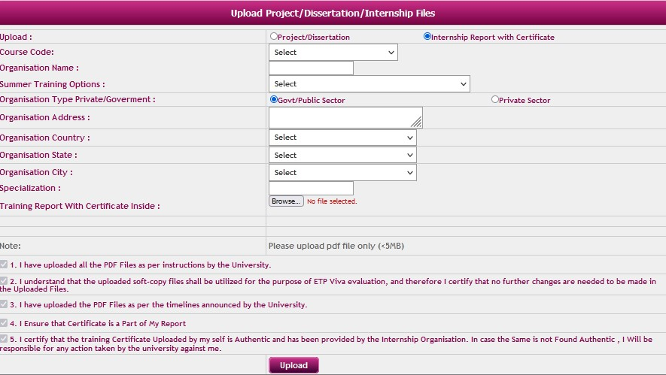

**Step 2: Select Course Code >Fill/Choose Relevant Details> Upload File (less than 5MB) > Read Notes>**

**Click Upload**

**NOTE:**

1) Upload Final Report with **Training** **Certificate** inside the report **(less than 5 MB) for all 3 options**